🕵️ Linux Incident Investigation & Troubleshooting

📘 Scenario Overview
During the first major testing phase of Project Phoenix, the application experienced critical failures. With the senior DevOps engineer unavailable, the responsibility fell on me to investigate system logs, configuration files, and environment discrepancies using Linux command-line tools.
This lab simulates a real-world incident response scenario, requiring structured analysis, evidence collection, and configuration comparison to identify root causes and restore system stability.

🎯 Investigation Objectives
- Extract critical application errors from log files
- Identify possible system-level issues from kernel messages
- Review web server configuration for performance bottlenecks
- Compare staging vs. production configurations
- Detect missing files between server environments

🔎 Step 1: Analyze Application Logs for Errors

Task
Filter the application log file to extract all error messages.

Command Used

grep "ERROR" ~/project/logs/app.log > ~/project/error_report.txt

Result
- Created error_report.txt
- File contains only log entries with the keyword ERROR
- Enables focused troubleshooting without noise
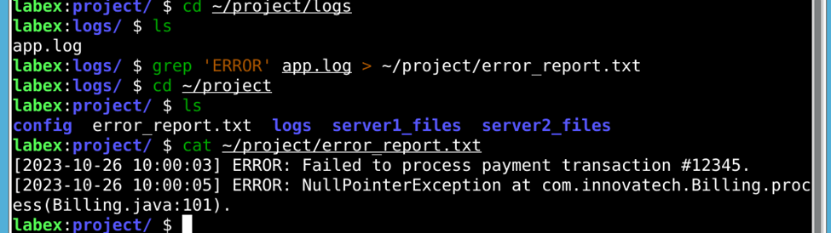

🖥️ Step 2: Investigate Kernel Boot Messages

Purpose
Application errors can stem from underlying system or hardware issues.

Command Used
sudo dmesg | grep -iE "fail|error" > ~/project/boot_issues.txt

Key Techniques
- dmesg to read kernel ring buffer
- Case-insensitive search with -i
- Multiple pattern matching using -E
- Output redirection to preserve evidence

Result
- Created boot_issues.txt
- Captured kernel-level warnings and errors for review
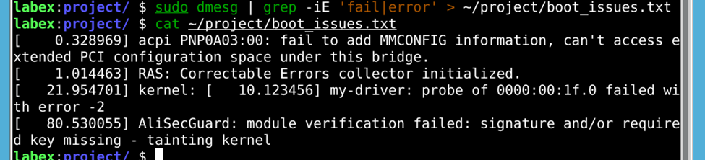

🌐 Step 3: Examine Web Server Configuration

Objective
Identify possible misconfiguration in the Nginx setup that could impact performance.

Command Used
grep "worker_processes" ~/project/config/nginx.conf >> ~/project/error_report.txt

Outcome
- Appended (not overwritten) configuration data
- Centralized application errors and relevant configuration in one report
- Enabled correlation between errors and server settings
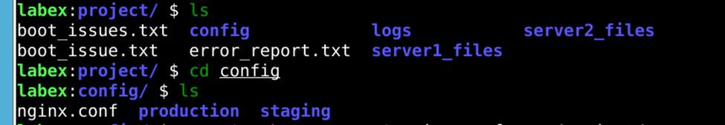
- 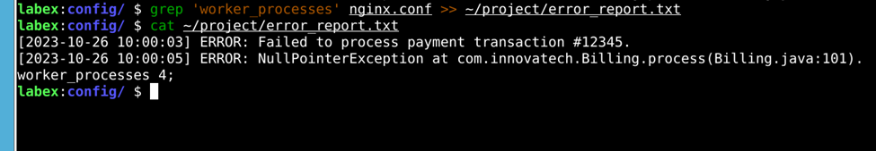

🧪 Step 4: Compare Staging vs Production Configuration Files

Purpose
Configuration drift between environments is a common cause of production failures.

Command Used
diff ~/project/config/staging/app.conf ~/project/config/production/app.conf > ~/project/config_diff.txt

Result
- Created config_diff.txt
- Identified configuration mismatches impacting production behavior
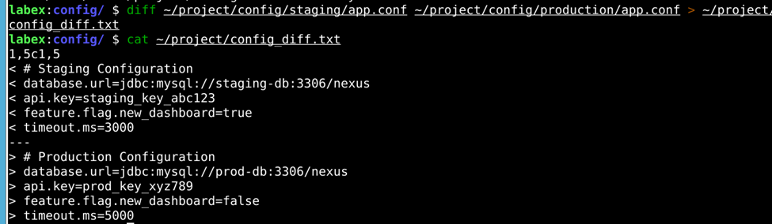

🗂️ Step 5: Verify Directory Consistency Between Servers

Scenario
Production server may be missing files present in staging due to a failed deployment.

Command Used
diff /home/labex/project/server1_files /home/labex/project/server2_files > /home/labex/project/missing_files.txt

Outcome
- Generated missing_files.txt
- Revealed files present in staging but missing in production
- Confirmed incomplete deployment as a contributing factor

🧠 Skills Demonstrated
- Incident response methodology
- Log analysis with grep
- Kernel diagnostics using dmesg
- Configuration auditing
- Environment comparison with diff
- Command pipelines and output redirection
- Evidence preservation and reporting

